Mathematical Notation

🌟 Definition
# Source: AI Source: Provided by: [Data Path: Persons Table -> ID Column: 1, Name_En Column: Motasem Essam] -> From: [ChatGPT] on [5/29/2026]
Mathematical notation is the system of symbols, signs, and written forms used to represent mathematical ideas, numbers, operations, relationships, and structures in a precise and compact way.
It is part of mathematical language that allows complex ideas to be written briefly and clearly.

🎯 Purpose of Mathematical Notation
# Source: AI Source: Provided by: [Data Path: Persons Table -> ID Column: 1, Name_En Column: Motasem Essam] -> From: [ChatGPT] on [5/29/2026]
- To express mathematical ideas clearly and precisely
- To shorten long verbal descriptions
- To standardize communication in mathematics
- To avoid ambiguity in expressions
- To make calculations and reasoning easier

📚 Main Components of Mathematical Notation

1. Numbers and Symbols
# Source: AI Source: Provided by: [Data Path: Persons Table -> ID Column: 1, Name_En Column: Motasem Essam] -> From: [ChatGPT] on [5/29/2026]
Represent quantities.
Examples:
- 1, 2, 3
- π, e

2. Operation Symbols
# Source: AI Source: Provided by: [Data Path: Persons Table -> ID Column: 1, Name_En Column: Motasem Essam] -> From: [ChatGPT] on [5/29/2026]
Represent mathematical operations.
Examples:
- + (addition)
- − (subtraction)
- × (multiplication)
- ÷ (division)

3. Relation Symbols
# Source: AI Source: Provided by: [Data Path: Persons Table -> ID Column: 1, Name_En Column: Motasem Essam] -> From: [ChatGPT] on [5/29/2026]
Show relationships between values.
Examples:
- = (equal)
- ≠ (not equal)
- < (less than)
- > (greater than)

4. Variable Notation
# Source: AI Source: Provided by: [Data Path: Persons Table -> ID Column: 1, Name_En Column: Motasem Essam] -> From: [ChatGPT] on [5/29/2026]
Represents unknown or changing values.
Examples:
- x, y, z

5. Function Notation
# Source: AI Source: Provided by: [Data Path: Persons Table -> ID Column: 1, Name_En Column: Motasem Essam] -> From: [ChatGPT] on [5/29/2026]
Represents relationships between inputs and outputs.
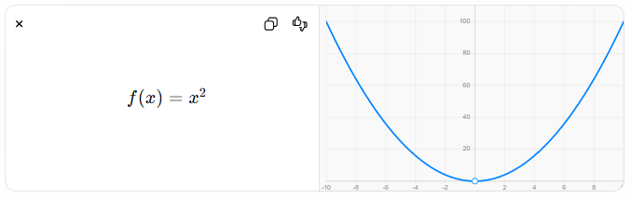
$$f(x)=x^{2}$$

6. Set Notation
# Source: AI Source: Provided by: [Data Path: Persons Table -> ID Column: 1, Name_En Column: Motasem Essam] -> From: [ChatGPT] on [5/29/2026]
Represents collections of objects.
$$A=\{1,2,3\}$$

7. Summation and Special Symbols
# Source: AI Source: Provided by: [Data Path: Persons Table -> ID Column: 1, Name_En Column: Motasem Essam] -> From: [ChatGPT] on [5/29/2026]
Used in advanced mathematics.
Examples:
- ∑ (summation)
- ∫ (integral)
- ∀ (for all)
- ∃ (there exists)

🧩 Examples of Mathematical Notation

Example 1: Equation
# Source: AI Source: Provided by: [Data Path: Persons Table -> ID Column: 1, Name_En Column: Motasem Essam] -> From: [ChatGPT] on [5/29/2026]
$$2x+3=7$$

Example 2: Geometry Formula
# Source: AI Source: Provided by: [Data Path: Persons Table -> ID Column: 1, Name_En Column: Motasem Essam] -> From: [ChatGPT] on [5/29/2026]
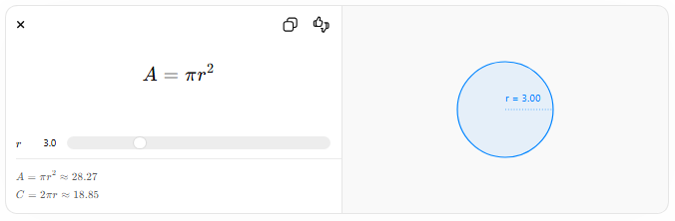
$$A=πr^{2}$$
$$r$$
$$A=πr^{2}≈28.27$$
$$C=2πr≈18.85$$
r = 3.00

Example 3: Logical Statement
# Source: AI Source: Provided by: [Data Path: Persons Table -> ID Column: 1, Name_En Column: Motasem Essam] -> From: [ChatGPT] on [5/29/2026]
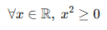
$$∀x∈R, x^{2}≥0$$

🔗 Relationship to Other Concepts
# Source: AI Source: Provided by: [Data Path: Persons Table -> ID Column: 1, Name_En Column: Motasem Essam] -> From: [ChatGPT] on [5/29/2026]
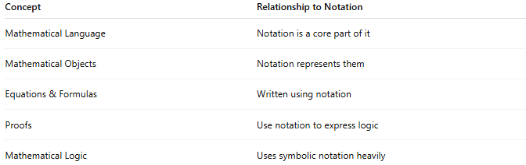
Concept | Relationship to Notation
Mathematical Language | Notation is a core part of it
Mathematical Objects | Notation represents them
Equations & Formulas | Written using notation
Proofs | Use notation to express logic
Mathematical Logic | Uses symbolic notation heavily

📖 Notation vs Language vs Symbols
# Source: AI Source: Provided by: [Data Path: Persons Table -> ID Column: 1, Name_En Column: Motasem Essam] -> From: [ChatGPT] on [5/29/2026]
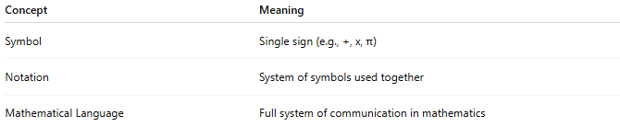
Concept | Meaning
Symbol | Single sign (e.g., +, x, π)
Notation | System of symbols used together
Mathematical Language | Full system of communication in mathematics

🧠 Simple Analogy
# Source: AI Source: Provided by: [Data Path: Persons Table -> ID Column: 1, Name_En Column: Motasem Essam] -> From: [ChatGPT] on [5/29/2026]
Mathematical notation is like a short code or alphabet:
- Instead of writing long sentences
- We use symbols to represent ideas quickly and clearly
Example:
- “The area of a circle is pi times radius squared”
becomes
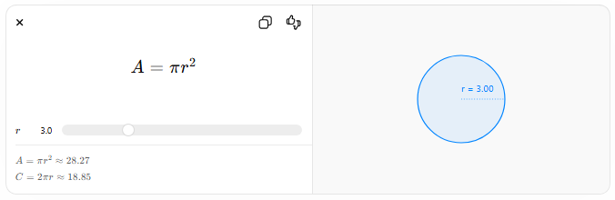
$$A=πr^{2}$$
$$r$$
$$A=πr^{2}≈28.27$$
$$C=2πr≈18.85$$
r = 3.00

🧭 Summary
# Source: AI Source: Provided by: [Data Path: Persons Table -> ID Column: 1, Name_En Column: Motasem Essam] -> From: [ChatGPT] on [5/29/2026]
Mathematical notation is the system of symbols used to represent mathematical ideas in a clear, short, and universal way. It is an essential part of mathematical language that helps express numbers, formulas, equations, and logical statements efficiently.

